9.27: 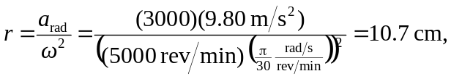

so the diameter is more than 12.7 cm, contrary to the claim.

